**Weighted Linear Regression**

|  |  |
| --- | --- |
| |  | | --- | | > Fluo.Matrix = matrix( c(  4,22,44,60,75,104,  3,20,46,63,81,109,  4,21,45,60,79,107,  5,22,44,63,78,101,  4,21,44,63,77,105), byrow=T,ncol=6)  > Fluo.Matrix  [,1] [,2] [,3] [,4] [,5] [,6]  [1,] 4 22 44 60 75 104  [2,] 3 20 46 63 81 109  [3,] 4 21 45 60 79 107  [4,] 5 22 44 63 78 101  [5,] 4 21 44 63 77 105  > | |

Compute the mean and standard deviation for each column.

|  |
| --- |
| > apply(Fluo.Matrix,2,mean)  [1] 4.0 21.2 44.6 61.8 78.0 105.2  > apply(Fluo.Matrix,2,sd)  [1] 0.7071068 0.8366600 0.8944272 1.6431677 2.2360680 3.0331502 |

Fitting a linear model based on the full data

|  |  |
| --- | --- |
| |  | | --- | | > Fit2 = lm(Fluo.M ~ Conc.M)  > summary(Fit2)  Call:  lm(formula = Fluo.M ~ Conc.M)  Residuals:  Min 1Q Median 3Q Max  -7.1924 -1.7410 0.6248 1.4419 6.9905  Coefficients:  Estimate Std. Error t value Pr(>|t|)  (Intercept) 2.92381 0.97589 2.996 0.00567 **  Conc.M **1.98171** 0.03223 61.482 < 2e-16 ***  ---  Signif. codes: 0 ‘***’ 0.001 ‘**’ 0.01 ‘*’ 0.05 ‘.’ 0.1 ‘ ’ 1  Residual standard error: 3.015 on 28 degrees of freedom  Multiple R-squared: 0.9926, Adjusted R-squared: 0.9924  F-statistic: 3780 on 1 and 28 DF, p-value: < 2.2e-16  > plot(Conc.M,Fluo.M,pch=18,col="red")  > abline(coef(Fit2)) | |

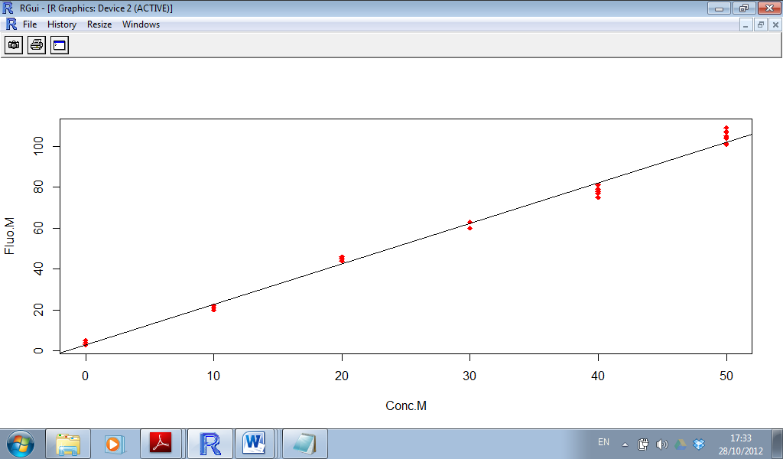

|  |
| --- |
| > summary(Fit3)  Call:  lm(formula = Fluo.mean ~ Conc, weights = weights)  Residuals:  1 2 3 4 5 6  0.7772 -2.4187 2.1963 -0.3705 -1.8963 1.2426  Coefficients:  Estimate Std. Error t value Pr(>|t|)  (Intercept) 3.48066 1.15736 3.007 0.0397 *  Conc 1.96315 0.06765 29.018 8.4e-06 ***  ---  Signif. codes: 0 ‘***’ 0.001 ‘**’ 0.01 ‘*’ 0.05 ‘.’ 0.1 ‘ ’ 1  Residual standard error: 2.034 on 4 degrees of freedom  Multiple R-squared: 0.9953, Adjusted R-squared: 0.9941  F-statistic: 842 on 1 and 4 DF, p-value: 8.396e-06 |

The Regression Equation for the Weighted Regression Model is

***Abso.fitted = 3.48 + 1.96 Conc***

Both terms are significant(*)and(***)respectively.